Introduction of 8237

* Direct Memory Access (DMA) is a method of allowing data to be moved from one location to another in a computer without intervention from the central processor (CPU).
* It is also a fast way of transferring data within (and sometimes between) computer.
* The DMA I/O technique provides direct access to the memory while the microprocessor is temporarily disabled.
* The DMA controller temporarily borrows the address bus, data bus and control bus from the microprocessor and transfers the data directly from the external devices to a series of memory locations (and vice versa).

Basic DMA Operation:

* Two control signals are used to request and acknowledge a direct memory access (DMA) transfer in the microprocessor-based system.
  1. The HOLD signal as an input(to the processor) is used to request a DMA action.
  2. The HLDA signal as an output that acknowledges the DMA action.
* When the processor recognizes the hold, it stops its execution and enters hold cycles.
* HOLD input has higher priority than INTR or NMI.
* The only microprocessor pin that has a higher priority than a HOLD is the RESET pin.
* HLDA becomes active to indicate that the processor has placed its buses at high-impedance state.

Basic DMA Definitions

* Direct memory accesses normally occur between an I/O device and memory without the use of the microprocessor.
  1. A DMA read transfers data from the memory  
     to the I/O device.
  2. A DMA write transfers data from an I/O device  
     to memory.
* The system contains separate memory and I/O control signals.
* Hence the Memory & the I/O are controlled simultaneously
* The DMA controller provides memory with its address, and the controller signal selects the I/O device during the transfer.
* Data transfer speed is determined by speed of the memory device or a DMA controller.
* In many cases, the DMA controller slows the speed of the system when transfers occur.
* The serial PCI (Peripheral Component Interface) Express bus transfers data at rates exceeding DMA transfers.
* This in modern systems has made DMA is less important.

CPU having the control over the bus

When DMA operates

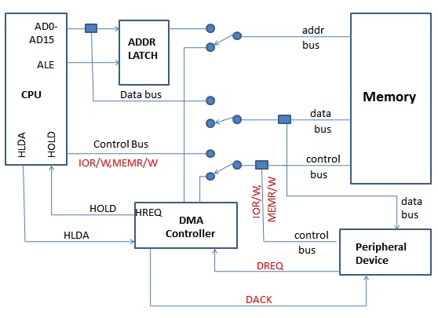

The 8237 DMA Controller

* The 8237 supplies memory & I/O with control signals and memory address information during the DMA transfer.
* It is actually a special-purpose microprocessor whose job is high-speed data transfer between memory and I/O

• 8237 is not a discrete component in modern microprocessor-based systems.

• It appears within many system controller chip sets

• 8237 is a four-channel device compatible with 8086/8088, adequate for small systems.

• Expandable to any number of DMA channel inputs

• 8237 is capable of DMA transfers at rates up to 1.6MB per second.

• Each channel is capable of addressing a full  
64K-byte section of memory.